Official league roster - BASKETBALL
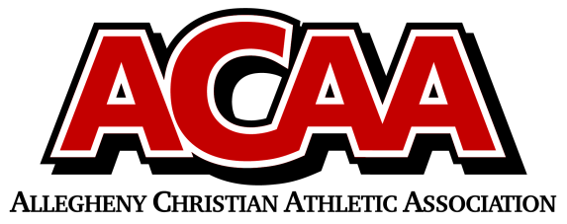
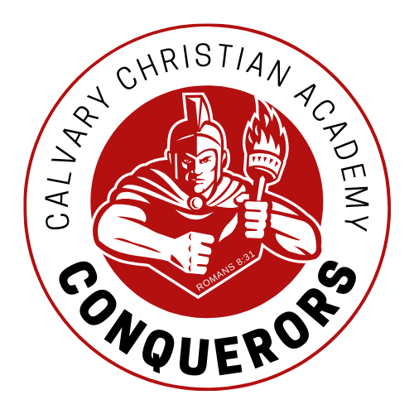
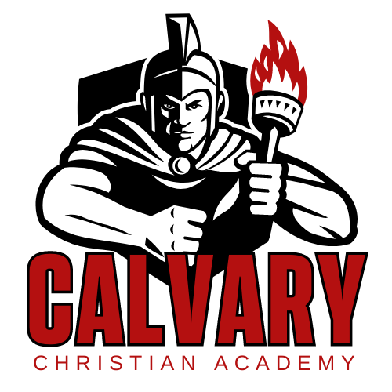

School Name: Calvary Christian Acad.
Team Colors: red/gold/white
Overall Wins ___ Losses ____ Ties ___
ACAA Wins ___ Losses ____ Ties ___ OPPONENT: __________________________
Date: _________
Number | Name | Year | Position | Height | Homeschool
10 | Paiton Zimmerman | Sr. | Guard
20 | Micah Lloyd | Sr. | Guard
12 | William Lane | Jr. | Forward
11 | Cole Zeiders | So. | Guard
14 | Jackson Suttles | F | Guard
23 | Jacob Anders | F | Guard
3 | Clayton Ayers | F | Guard
13 | Vanner Henney | F | Forward
2 | Harvey Anderson | 8th | Guard |  | X
25 | Zachary Feaster | 8th | Guard
4 | Ezra Lloyd | 8th | Guard |  | X
MGR
 | *Denotes team captain

Head Coach: Hunter rodgers
Asst. Coach: charlie marshall
Asst. Coach: ben kilian

Official ACAA League Team Roster. to be submitted to the scorer’s table before each game.

